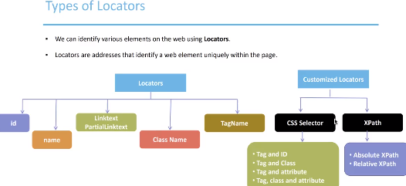

Customize locators (CSS, X-Path) - we use when we can not reach the element, for example if it has not attributes known to Selenium.